jQuery Mobile
Lab Book

Document Revision History

Date | Revision No. | Author | Summary of Changes
01-Sep-2012 | 0.1 | Shrilata | Initial Draft

Table of Contents
Document Revision History 2
Table of Contents 3
Getting Started 4
Overview 4
Setup Checklist for jQuery Mobile 4
Instructions 4
Learning More (Bibliography if applicable) 4
Problem Statement/ Case Study 5
Lab 1. jQuery Mobile Basics 7
1.1: Creating jQuery Page and view it in a Mobile browser 7
<<Streched Assignment>> 9
1.2: Working with themes 9
Step 4: Output will appear as shown in the following figure 10
TODO Assignments 11
1.3: using jQuery in jQuery Mobile 11
Lab 2. jQuery Mobile Pages 14
2.1: Creating Login Page with custom Icons using custom CSS 14
TODO Assignments 16
2.2: Retrieving XML using Ajax 17
<<Streched Assignment>> 18

Getting Started

Overview
This lab book is a guided tour for learning jQuery Mobile. It comprises solved examples and ‘To Do’ assignments. Follow the steps provided in the solved examples and work out the ‘To Do’ assignments given.

Setup Checklist for jQuery Mobile
Here is what is expected on your machine in order for the lab to work.
Minimum System Requirements
- Intel Pentium 90 or higher (P166 recommended)
- Microsoft Windows XP or above.
- Memory: 256MB of RAM (512MB or more recommended)
- Safari 5.1.1 or higher, Mozilla Firefox 13.0 or higher, Google Chrome 20.0 or higher
- Mobile Emulator like Android emulator or Opera Mobile Emulator 12 or higher
- jquery.mobile-1.2.0 downloaded from jQueryMobile.com

Please ensure that the following is done:
- A text editor like Notepad, Editplus

Instructions
- All the resources(images,scripts etc) required for this lab book is available in LabResource Folder.
- Create a directory by your name in drive <drive>. In this directory, create a subdirectory jQueryMobile_assign. For each lab exercise create a directory as lab <lab number>.
- You may also look up the on-line help provided in the http://jquerymobile.com/
- The faculty will introduce you to the editor to be used.

Learning More (Bibliography if applicable)
- jQuery Mobile by Jon Reid. O’Reilly publications
- jQuery Mobile First Look by Giulio Bai. Packt publications
- jQuery Mobile Web Development Essentials by Raymond Camden. Packt publications
- Pro jQuery Mobile by Brad Broulik. Apress publications

Problem Statement/ Case Study

Develop a mobile web application for the iLearn site.

The home page must display a list of top-level items as shown below. Clicking on each item in list must take user to different parts of the application.

You may extend this list, make changes , bring more links, add different icons etc. The below shown image is an approximate example of what type of web application is required.



Create Web Pages (Day01)
- Add pages for displaying extensive information for all the links.
- For the “Search Catalog”, offer user a search text box that will enable him to provide data to search on.
- For the “TRIM- trg request”, offer user a complete form to enter his trg request. This must provide user with:
  - Drop down of all courses on offer
  - Radio buttons to select location
  - Date picker to select date from which trg is required
  - Text box to accept username
  - Text area to accept detail description of the trg request
  - Collapsible list to accept SBU details (And any other information that you wish to receive from requestor)
- For the “Contact Us”, allow user to enter his email-id and display a submit button

Web Page Layout (Day02)
Create the listview that will bring all the pages created on day-1 together.

- jQuery Mobile Basics

Goals | - Using the viewport meta tag to control layout on mobile browsers  - Working with Themes.  - Using jQuery in jQuery Mobile
Time | 180 minutes

1.1: Creating jQuery Page and view it in a Mobile browser
Create a jQuery Mobile page to with two pages with header, footer and content. Provide links in the content page to navigate between first and second page. View the created page using Mobile Emulator (Opera Mobile Emulator)
Solution:
Step 1: Create two pages in Lab1-1.html and provide navigation between them as shown below

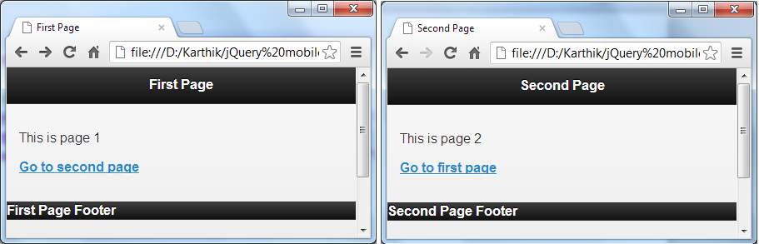
Figure 1Lab1-1.html in Chrome

Step 2: Open Opera Mobile Emulator with HTC Hero (320x480) profile
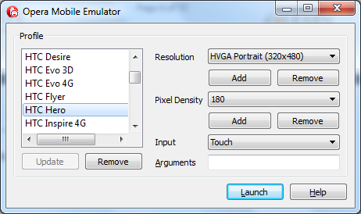

Figure 2 Opera Mobile Emulator
Step 3: Access Lab1-1.html in Opera mobile Emulator by typing the file location like given below.

file://localhost/<FilePath>

eg :- file://localhost/D:/Karthik/jQuerymobile/Labsolutions/Solutions/Lab1-1.html

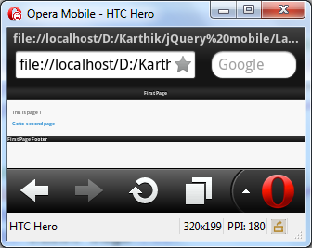

 Page created is not optimized for mobile browsers. We can fix this by providing viewport metatag.

Step 4: Fix the problem by providing meta tag with in the head tag as given below

<meta name="viewport" content="width=device-width, initial-scale=1, maximum-scale=1">.

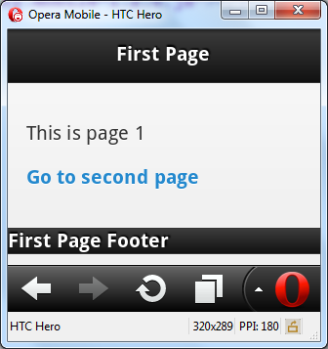

<<Streched Assignment>>
Try the program with different profiles like Nokia E63(240X320) with different profiles with different resolutions. Observe the changes when the viewport meta tag is changed like given below.

<meta name="viewport" content="width=device-width, initial-scale=1">

1.2: Working with themes
Step 1: Create jQuery page (Lab1-2.html) as shown below

<!DOCTYPE html>
<html>
<head>
<meta name="viewport" content="width=device-width, initial-scale=1">
<!—Refer the three files that jQuery Mobile needs to work -->
</head>
<body>
<section id="themepage" data-role="page" data-theme="b">
<header data-role="header" data-theme="a">
<h1>Theme "a" header</h1>
</header>
<div data-role="content">
<button data-theme="b">Theme "b" button</button>
</div>
<header data-role="footer" data-theme="c">
<h1>Theme "c" footer</h1>
</header>
</section>
</body>
</html>

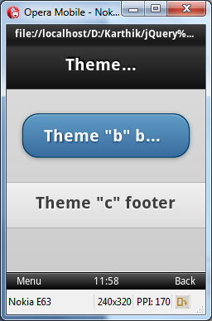

Step 2: Extract the custom theme (iGATE theme.zip available in lab resource folder) created using jQuery Theme Roller. Copy the file named iGate.css into jquery.mobile-1.2.0 folder.

Step 3: Refer iGate.css in the head tag like shown below in Lab1-2.html

<head>
<meta name="viewport" content="width=device-width, initial-scale=1">
<link rel="stylesheet" href="../jquery.mobile-1.2.0/jquery.mobile-1.2.0.css" />
<link rel="stylesheet" href="../jquery.mobile-1.2.0/iGate.css" />
<script type="text/javascript" src="../jquery-1.8.2.js"></script>
<script type="text/javascript" src="../jquery.mobile-1.2.0/jquery.mobile-1.2.0.js"></script>
</head>

Step 4: Output will appear as shown in the following figure

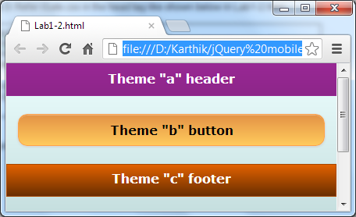

TODO Assignments
Assignment-1: Create 3 jQuery Mobile Pages with navigation which uses the custom theme (igate.css) with 3 swatches (A, B, C) like given below.

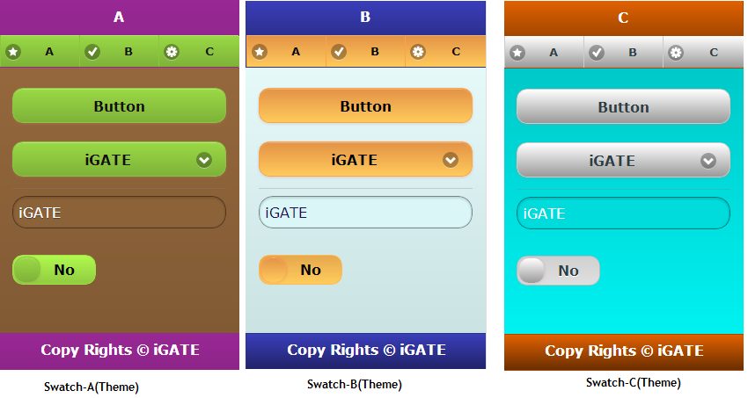

1.3: using jQuery in jQuery Mobile
Step 1: Create jQuery page (Lab1-3.html) as shown below

<!DOCTYPE html>
<html>
<head>
<meta name="viewport" content="width=device-width, initial-scale=1">
</head>
<body>
<section id="jQuerypage" data-role="page">
<header data-role="header">
<h1>Adding Numbers using jQuery</h1>
</header>
<div data-role="content">
<fieldset data-role="fieldcontain">
<label for="txtFirstNumber">First Number:</label>
<input type="text" name="txtFirstNumber" id="txtFirstNumber"/>
<label for="txtSecondNumber">Second Number:</label>
<input type="text" name="txtSecondNumber" id="txtSecondNumber"/>
<label for="txtResult">Result:</label>
<input type="text" name="txtResult" id="txtResult" value="0"/>
<a id="btnAdd" data-role="button" href="#resultpage">Add</a>
</fieldset>
</div>
</section>

<section id="resultpage" data-role="dialog">
<div data-role="header">
<h1>Result</h1>
</div>
<div data-role="content">
<div id="results" />
</div>
</section>

<script>

$(document).ready(function() {
$("#txtResult").attr("readonly","readonly");
wireEvents();
});

$("#jQuerypage").live('pageinit', function (evt) {
$("#txtResult").attr("readonly","readonly");
});

$('#resultpage').live('pageshow', function(){

var firstNumber = $(this).data('firstNumber') ? $(this).data('firstNumber') : "0";
var secondNumber = $(this).data('secondNumber') ? $(this).data('secondNumber') : "0";
var result = $(this).data('result') ? $(this).data('result') : "0";
$('#results').text("Addition of "+firstNumber+" and "+secondNumber+" is "+result);
});

function wireEvents(){
$("#btnAdd").bind('click',btnAddClick);
}
function btnAddClick(){
var firstNumber = eval($("#txtFirstNumber").val());
var secondNumber = eval($("#txtSecondNumber").val());
var result = firstNumber+secondNumber;
$("#txtResult").val(result);
$('#resultpage').data({"firstNumber":firstNumber,"secondNumber":secondNumber,"result":result});
}
</script>
</body>
</html>

Step 2: Output will appear as shown in the following figure

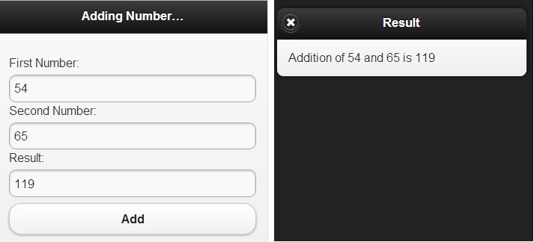
- jQuery Mobile Pages

Goals | - Using custom css to desing jQuery Mobile Pages  - Working with XML & JSON
Time | 180 minutes

2.1: Creating Login Page with custom Icons using custom CSS
Create a jQuery Mobile login page with custom css
Solution:
Step 1: Create a jQuery mobile page (Lab2-1.html) as shown below

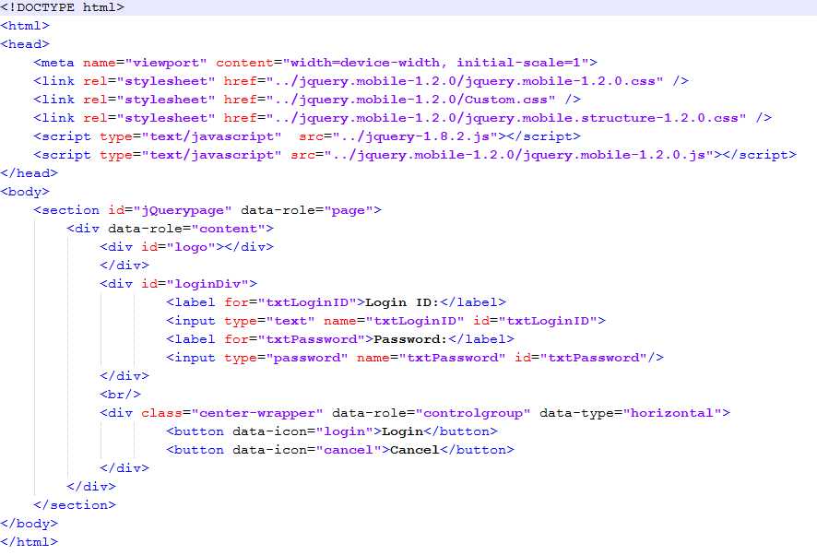
Step 2: Create Custom.css as shown below
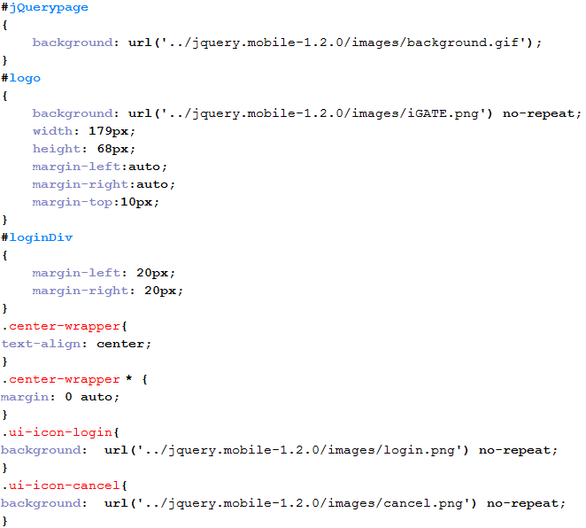
Step 3: Output will appear as shown in the following figure


TODO Assignments
Assignment-1: Create a jQuery mobile page as shown below using Custom CSS. Use the images from Lab Resources.

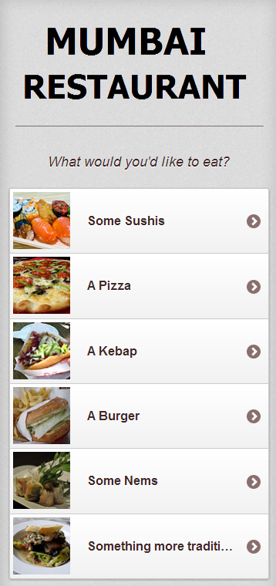

2.2: Retrieving XML using Ajax
Create a jQuery Mobile page which retrieves XML asynchronously and populate in dropdownlist
Solution:
Step 1: Create a jQuery mobile page (Lab2-3.html) as shown below
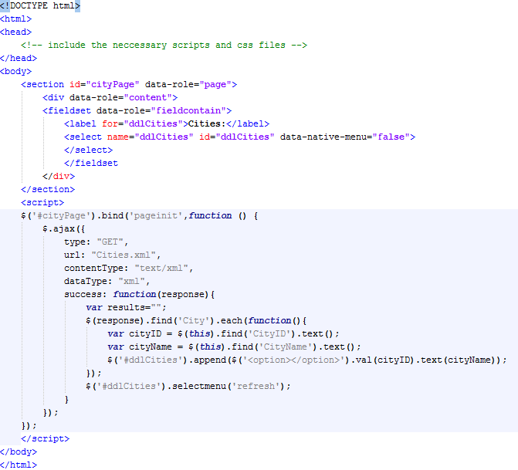

Cities.xml

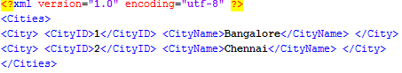

Step 2: Output will appear as shown in the following figure
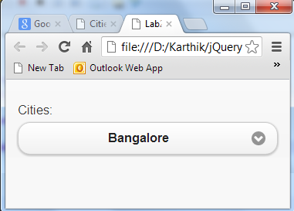

Use Safari or Firefox to run this application. To Run this application in Google Chrome. Press Win+R Key to open Run window and type
chrome.exe --allow-file-access-from-files

<<Streched Assignment>>
Try the above program with jSON data given below.

[
{"CityID" : 1, "CityName" : "Bangalore" },
{"CityID" : 2, "CityName" : "Chennai" },
{"CityID" : 3, "CityName" : "Hyderabad" },
{"CityID" : 4, "CityName" : "Mumbai" },
{"CityID" : 5, "CityName" : "Noida" },
{"CityID" : 6, "CityName" : "Pune" }
]

